Modern Mathematics

Principle of counting
Factorial
Factorial of natural number is defined as the product of all the consecutive natural numbers from l to that particular number. For example factorial 5 is 1 x 2 x 3 x 4 x 5. ‘Factorial word is represented with a symbol ‘!’. Or ‘L’. For example factorial of 5 is written as L5 or 5!
Example:
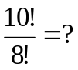
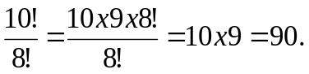
Note : Factorial of zero is 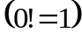
Basic principle of counting
To make the counting simpler there are two basic principles
1. Basic principle of multiplication:
Suppose that there are two ways of reaching railway station from your home and from railway station there are three way of reaching airport. So the total number of way of reaching airport from your home is 2 x 3 = 6
If a function can be done in x ways and for each of these functions the other function can be done in y ways then both the function together can be done in x x y ways.
Example
There are 10 boys and 8 girls in a school. For post class monitor the teacher has to select one boy and one girl. In how many ways can he do this function?
Solution:
For every boy he can select any one of the 8 girls. So for one boy he has 8 choices.
So for 10 boy he has 10 x 8 = 80 choices
Which is nothing but 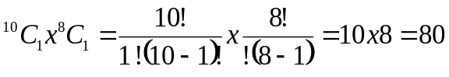
2. Basic principle of addition:
Suppose you are at a railway station and you want to go to either airport or your home. So you can do this function in 2 ways (if you are going home) + 3 ways (if you are going airport) = 5 days.
If a function can be done in x ways and the other function can be done in y ways then either of the function can be done x + y ways.
Example 1:
There are 10 boys and 8 girls in a school, for the post class monitor, the teacher wants to select either a boy or a girl. In how many ways can he do this function?
Solution
He can select one boy out of 10 days in 10 ways.
He can select one girl out of 8 girls in 8 ways.
He can select either a boy or girl in 10 + 8 = 18 ways.
Note :
1. If all the functions are correlated, then basic principle of multiplication is used
2. If all the functions are independent, then basic principle of addition is used.
Example 2
How many three digit numbers are there?
Solution:
We know that there are 10 digits 0, 1, 2, 3, 4, 5, 7, 8, 9
‘0’ can’t be at the hundreds place
So 100th place can be filled in 9 ways
10th place can be filled in 10 ways.
Unit place can be filled in 10 ways.
So the total number of three digits numbers = 9 x 10 x 10 = 900
Example 3:
How many three digit numbers are there in which all digits are distinct?
Solution
100th place can be filled in 9 ways.
10th place can be filled in 9 ways.
Units place can be filled in 8 ways.
So the total number of three digit numbers in which all digits are
distinct = 9 x 9 x 8 = 648
Example 4 :
There are 5 multiple choice questions in an examination. Fist three questions have 4 choices each and other two questions have 5 choices each. How many sequences of answers are possible?
Solution
Each one of the first three questions can be solved in 4 ways, and each one of the last two questions can be solved in 5 ways.
So the total number of different sequences is 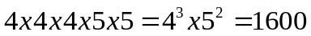
Example 5:
How many even numbers less than 1000 can be formed by using the digits 2, 4, 3 and 5, if the repetition of the digits is allowed?
Solution:
All the numbers of one digit, two digits and three digits are less than 1000. So take these cases one by one
1. Single digit even number 2 and 4
2. Two digit even numbers: Unit’s place can be filled in 2 ways, by 2 and 4 because unit place digit must be an even number.
Ten’s place can be filled in 4 ways.
So the total number of two digit even number = 2 x 4 = 8
3. Three digit even numbers
Unit’s place can be filled in 2 ways.
Hundred’s place can be filled in 4 ways.
So the total number of three digits even numbers = 2 x 4 x 4 = 32
Total number of three digits even numbers (by using the digit 2, 4, 3 and 5) less then 1000 = 2 + 8 + 32 = 42
Permutations
Suppose there are three persons A, B, and C for the post of president and vice president of an organization and we have to select two persons. We can do it in 3! ways. For example, (a, b), (b, c), (a, c), (b, a), (c, b) and (c, a). Here, the first person can be president and the second person can be the vice president, means here we are talking about the order of arrangement.
The arrangements of a number of things taking some or all of them at a time are called permutations.
For example, if there are n number of persons and we have to select r person at a time, then the total number of permutations is denoted by
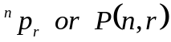
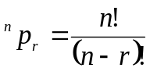
Example 1:
There are four persons A, B, C and D and at a time we can arrange only two persons, find the total number of arrangements.
Solution:
Total number of arrangements (permutations) is AB, BA, AC, CA, AD, DA, BC, CB, CD, BD and DB or we can say that out of 4 persons we have to arrange only 2 at a time, so the total number of permutations is 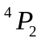
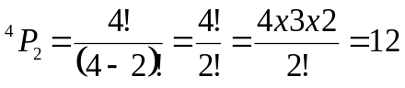
Example 2:
In the above questions, if all the persons are selected at t time, then how many arrangements are possible?
Solution
We have to arrange 4 persons, so this is 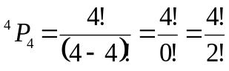
= 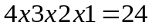
Example 3:
From 4 flags of different colours, how many different signals can be given, by taking any number of flags at a time?
Solution:
Signals can be given either taking all or some of the flags at a time.
By taking 1 flag, number of signals that can be given are = 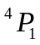
By taking 3 flags, number of signals that can be given are = 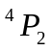
By taking 3 flags, number of signals that can be given are = 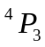
By taking 4 flags, number of signals that can be given are = 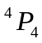
So the total number of signals = 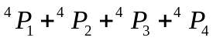
=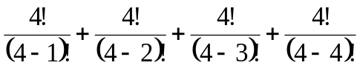
=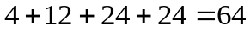
Example 4:
Find the number of ways in which 5 boys and 5 girls be seated in a row so that:
- All the boys sit together and all the girls sit together
- Boys and girls sit alternately
- No two girls may sit together
- All the girls are always together
- All the girls are never together
Solution
- All the boys can be arranged in 5! Ways and all the girls can be arranged in 5! Ways.
Now we have two groups (boys, girls) and these 2 groups can be arranged in 2! ways.
[boys – girls and girls-boys]
So total number of arrangements is 5! x 5! x 2! = 28,800
2. Boys and girls sit alternately, this can be arranged like this B G B G B G B G B G or G B G B G B G B G B
In the first case boys can be arranged in 5! and girls can be arranged in 5! in 5! ways.
In the second case also, the number of arrangement is same as first case
So the total number of arrange = 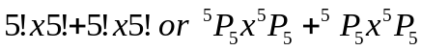
= 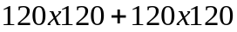
= 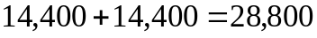 ways
3. No two girls many sit together – In this case _B_B_B_B_B_ there are 6 spaces where a girl can find her seat.
5 girls can be arranged in 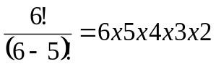
= 720 ways
5 boys can be arranged in
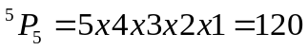 ways
Total number of arrangements = 720 x 120 = 86,400
4 When all the girls are always together, then treat then as one group. So now we have 5 boys and 1 group of 6 girls and this can be permutated in 6! Ways at the same time 5 girls in the group can be permutated in 5! ways, so total number of permutations is 6! X 5! = 720 x 120 = 86400
5 All the girls are never together
Total number of arrangements of 5 boys and 5 girls is 10!
Number of arrangements in which all the girls are always together
=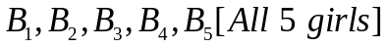
= 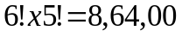
So number of arrangements in which all the girls we never together = total arrangement – number of arrangements when girls are always together.
= 10! – 6! X 5! = 3542400
Example 5:
Find out the number of permutation of the leters of the word FOLDER taking all the letters at a time?
Solution
Number of letters in the work FOLDER is 6.
So the number of arrangements = 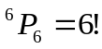
Alternate method:
First place can be filled by any one of the six letters. The second place can be filled by any one of the five remaining letters, the third place can be filled by any one of the four remaining letters and so on. So the total number of arrangements is 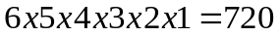
Permutation of alike things
If there are three different coloured balls, then they can be arranged in 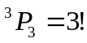 ways. But if all three balls are of the same colour then there is only one way of arranging them.
So number of arrangements
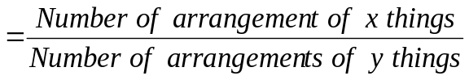 where
x = Number of elements and
y = Number of alike elements
Example 6:
Find out the Number of permutation of the letters of the word STUDENT taking all the letters at a time?
Solution
Number of letters in the word STUDENT = 7
Number of alike letters ‘T’ in the word = 2
So number of permutations
= 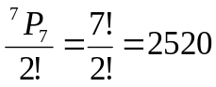
Example 7:
Find out the number of arrangements of the letters of the word
‘MATHEMATICS’ taking all the letters at a time.
Solution:
Number of the letters in the word ‘MATHEMATICS’ = 11
Alike letters ‘M’ is 2 in number, ‘A’ is
2 in number, ‘T’ is 2 in number
So, the number of permutations
=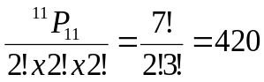
Since a number begging with 0 is not greater than a million, so total number of numbers beginning with
‘0’ is 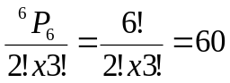
So total number of numbers greater than a million is 420 – 60 = 360.
Example 9:
How many four digit numbers greater than 5000 can be formed by using the digits, 4, 5, 6 and 7? If the repetition of the digits in the same number is not allowed.
Solution:
Total number of arrangements possible is 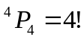
Total number of arrangements by using the digits 5, 6, and 7 is = 3!
So the total number of required arrangements is 4!-3!=24-6=18
Alternative method:
Thousand’s place can be filled in 3 ways.
Hundred’s place can be filled in 3 ways.
Ten’s place can be filled in 2 ways.
Unit’s place can be filled in 1 ways.
So total number of arrangements = 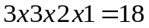
Example 10:
In Q, 9 find out the number of arrangement if the repetition of digits is allowed.
Solution:
If the repetition is allowed then the total number of arrangements is 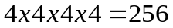 ways.
Because on the first place any one of the four number can come, similarly on the 2nd, 3rd and 4th place also. Total number of arrangements begging with 4 is 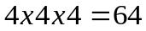.
So, total number of required arrangements = 256 – 64 = 192
Alternative method:
Thousand’s place can be filled in 3 ways
Hundred’s place can be filled in 4 ways.
Ten’s place ca be filled in 4 ways.
Unit’s place can be filled in 4 ways.
So the total number of arrangements = 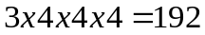
Combinations
Suppose there persons A, B and C for the post of president and vice president of an organization and we have to select two person. We can select either (a, b) or (b, c) or (a, c) = 3 ways because here we are talking about the selection, not about the order. Whether ‘a’ is a president or ‘b’ is a vice president or vice-versa, doesn’t matter.
Suppose there are 10 persons in class and we have to select any 3 persons at a point regardless of the order, it is a case of combination. If there are n number of things and we have to select some or all of them it is called combinations.
If out of x things we have to select 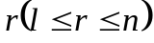, then the number of combinations = 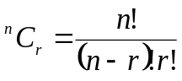
Difference between permutations and combinations
Suppose that there are five persons A, B, C, D and E and we have to choose two persons at a time then in
Permutation
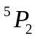
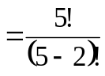
= 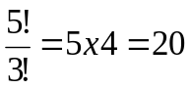
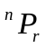
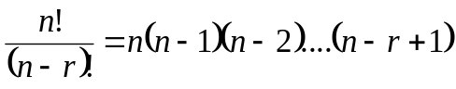
Combinations
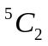
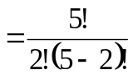
=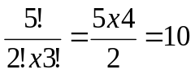
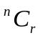
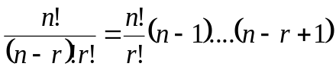
So it is clear that in permutations (rearrangement) order matters but in combinations (selections) order does not matters.
Example 11:
In a class of students there 5 boys and 6 girls. How many different committers of 3 boys and 2 girls can be formed?
Solution:
Out of 5 boys we have to select 3 boys, this can be done in 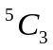 ways. Out of 6 girls we have to select 2 girls, this can be done in 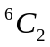 ways. So selection of 3 boys and 2 girls can be done in 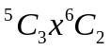 ways.
[Basic rule of multiplication]
=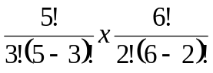
= 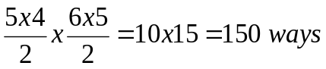
Example 12 :
If there are 10 persons in a party, and if each of them shake hands with other. How many hand shakes happen in the party?
Solution:
It is very obvious that when two persons shake # hands, it is counted as one handshake. So we can say that there are 10 hands and every combination of 2 hands will gives us one handshake.
= 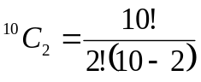
= 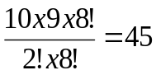
Example 13:
For the post of Maths faculty in Career Launcher there and 6 vacant seats. Exactly 2 seats are reserved for MBA’s . There are 10 applicants out of which 4 are MBA’s. In how man ways the selection can be made?
Solution
There are 4 MBA’s and 6 other candidates.
So we have to select 2 out of 4 and the rest 4 out of 6 other candidates. So the total number of ways of selection = 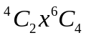
= 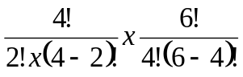
= 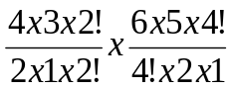
= 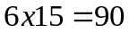 ways
Example 14:
There are 10 points out of which no three are collinear. By joining the points how many straight lines can be formed.
Solution
By joining any two points we will get one line.
So the total number of lines formed.
= 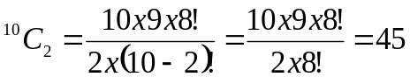
Example 15:
Find the number of diagonals that can be drawn by joining the vertices of a decagon.
Solution:
In decagon there are 10 vertices and by joining any two vertices we will get one line. So in a decagon total number of lines formed.
= 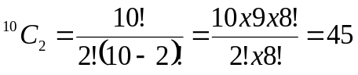
But out of these 45 lines, 10 lines will be the sides of the decagon. So total number of diagonals = 45 – 10 = 35
Example 16:
In the above question how many triangles can be formed?
Solution:
We know that in a triangle there are three vertices and by joining any three vertices and by joining any three pints we will get a triangle. So number of triangles formed.
= 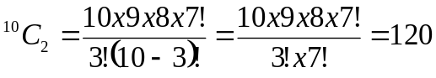
Example 17:
There are 5 boys and 6 girls. A combination of 4 is to be selected so that it must consist of at least one boy and one girl?
Solution
The different possibilities are
- 1 boys and 3 girls
- 2 boys and 2 girl
- 3 boy and 1 girl
In the first possibility total number of combination is 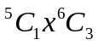
In the second possibility total number of combination is 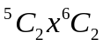
In the third possibility total number of combination is 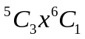
So the total number of combinations are
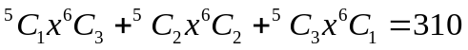
Circular combination
If n persons are seated around a circular table then the can be arranged in 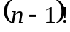 ways. For example: If three persons are there they can be arranged in 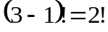 ways.
B
A
C
C
B

A
Probability
Suppose a magician approaches you and says that he has a dice and if he throws that dice number greater than 5 comes on the top, he will give you Rs. 20 other wise you will have to give Rs. 10 to him. What will you do? It has nothing to do with actual happenings. It just talk about the possibilities.
To know about the probability in a better way just take the above example.
When a dice is thrown then on the to either 1, 2, 3, 4, 5 or 6 can come. So we can say there are a total possibilities. Out of these 6 numbers, greater than 5 is only one number that is 6. So in you favour there is only 1 number that is 6 and against our (or our opponent) favour there are 5 numbers 1, 2, 3, 4 and 5. This indicates that your chance of winning. It means this game is not in your favour. Probability is defined as
Probability of a event = 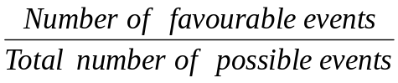
Like in the example given above
Probability of your winning = 
Probability of your losing = 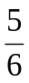
Possible events (sample space) :
It mean all those events which can occur in that scenario.
For example: If we have one dice and one coin then the possible outcomes are H1, H2, H3, H4, H5, H6, T1, T2, T3, T4, T5, T6
Note : Probability of an event can’t be less than 0 at the same time it can’t be more than 1.
Addition rule
Events :
Each possible outcome is called an event. Like the events of throwing a dice are 1, 2, 3, 4, 5 and 6.
Mutually exclusive :
When a particular event occurs the other particular event can’t happen it is called mutually exclusive event.
For example :
In the experiment of throwing a dice the event that possible outcomes are an odd number and the even that possible outcomes are an even number, are mutually exclusive (Because there is not any number which is odd as well as even).
Here, the probability of such even is given by P(E) = P(A) + P(B) where
P(E) = Probability of happing such mutually exclusive event.
P(A) = Probability of happening of even A .
P(B) = Probability of happening of event B
Not mutually exclusive events: When a particular event occurs the other particular event may also occur and vice versa or you can say that both events can occur simultaneously. It is called not mutually exclusive events.
For example :
In the experiment of throwing a dice the event that possible outcomes are odd and the event that possible outcomes are prime are not mutually exclusive, because there are certain numbers (like 3 and 5) which are both, so the probability of such event is given by P(E) = P(A) + P(B) – P(C) where
P(E) = Probability of happening of any or both of A an dB
P(A) = Probability of happening of event A
P(B) = Probability of happening of event B
P(C) = Probability of happening of event of C, which is an intersection of A and B.
Example 18:
In a single throw of a fair die what is the probability that the number on the top is more that 2?
Solution:
In the die there are 6 faces numbered 1, 2, 3, 4, 5, and 6
So, the total number of possible events = 1, 2, 3, 4, 5 and 6 = 6
and , the total number of favourable events = 3, 4, 5 and 6 = 4
So the required Probability is 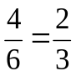
Example 19:
If two fair die are thrown simultaneously what is the probability that the sum of the numbers on the top faces is less than 4?
Solution:
Total number of possible events
= and so on. There will be 6 x 6 = 36 possible events. So the required probability = 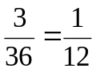
Example 20:
If out of 20 numbers from 1 to 20 Mr. X select a number at random . what is the probability that this number will be a multiple of 4?
Solution
Total number of possible events = 1, 2, 3, …. 20 = 20 in number.
Total number of favourable events = 4, 8, 12, 16 and 20 = 5 in number.
So the required probability = 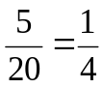
Example 21:
In the above example 20, what is the probability that this number will be a multiple of 4 or 7?
Solution:
Total number of possible events = 1, 2, …20 = 20 in number
Number divisible by 4 = 4, 8, 12, 16, 20 = 5 in number
Number divisible by 7 = 7 and 14 = 2 in number
Since from 1 to 20 ther is not any number which are divisible by both 4 and 7. It is a case of mutually exclusive events.
So number of possible outcomes = 5 + 2 = 7
So the required probability is = 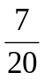
Example 22:
In the above example 20, what is the probability that this number is divisible by 2 and 4?
Solution :
The total number of possible events = 20 in number
Number divisible by 2 and 4 means the number should be divisible by 4 (LCM of 2 and 4 is 4) = 4, 8, 12, 16, 20=5 in number.
So the required probability is
Example 23:
In the above example 20, what is the probability that this number is divisible by 2 or 4?
Solution:
The total number of possible outcomes = 20 in number
Number divisible by 2 = 2, 4, 6, 8,. 10, 12, 14, 16, 18, 20 = 10 in number.
Number divisible by 4 = 4, 8, 12, 16 and 20 = 5 in number.
There are certain numbers which are divisible by both 2 and 4, so it is case of not mutually exclusive events.
Number divisible by both 2 and 4 are 4, 8, 12, 16 and 20 = 5 in number
So, the required probability = P(A) + P(B) – P(C)
= 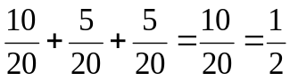
Set theory
Everything in the universe can be represented in the form of set or subset (subset is a part of the set). Like man is a subset of human beings which is again a subset of living beings and so on,
Suppose A = All natural numbers and B = All odd numbers and C = All even numbers, then B and C are subset of A.
Union and Intersection
Let A = {1, 2, 3, 4, 5, 6} and B = {4, 5, 8} then  = {1, 2, 3, 4, 5, 6, 8} (it is read as A union B) Union means collection.
 = {4, 5} (It is read A intersection B)
Intersection means common
Diagrammatic representation
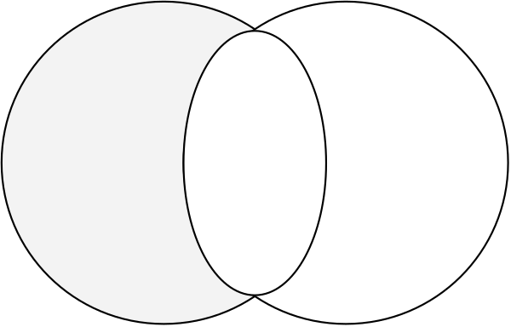
A
B
a.

Area including dotted lines and horizontal lines = A
Area including cross signs and horizontal lines = B
Only horizontal lines = Both A and B
Only dotted portion = Only A
Only cross sign = Only B
b.
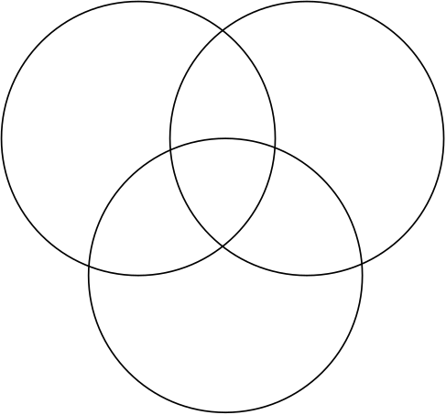
A
B
w
u
v
y
z
x

k
C

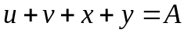
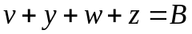
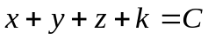
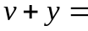A and B both
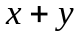 = A and C both
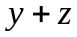= B and C both
y = All A, B and C
u = Only A
w = Only B
k = Only C
Formulae :
For two variables
For three variables
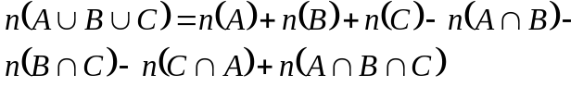
Example 23:
In a school there are 100 candidates and every student study at least one subject. 60 candidates study physics, and 80 candidates study biology. How many candidates study both physics and biology?
Physics
Biology
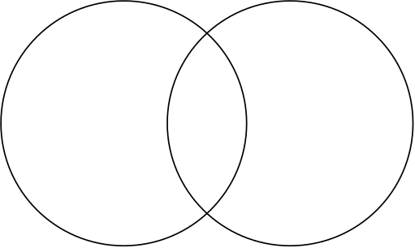

c
b
a

Solution
So, a + b = 60 and b + c = 80
So, a + 2b + c = 140
It is given that a + b + c = 100
b = 140 – 100 = 40
By formulae:
100 = 60 + 80 - 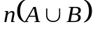
So 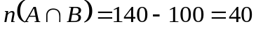
Example 24 :
In the above question find the number of students who study only one subject?
Solution
Number of students who study only one subject = Number of students who study only physics + number of study only physics + number of students who study only biology = 20 + 40 = 60
Example 25:
The given diagram indicates about the number of students who passed in different subject combinations. Assuming that all the student appeared for the exam, passed at least one subject. Find out the percentage of students who passed in at least two subjects?
Maths
Physics
15
20
15
10
30
40
20

Biology
Solution
The number of students who passed in at least two subjects.
=
Maths
Physics
15
20
15
10
30
40
20
Biology

The number of students who passed in at least two subjects.
=
Total number of students
=
So the percentage of students who passed at least in two subjects
= 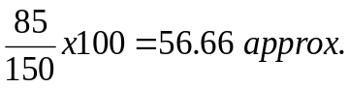
Example 26:
In a school there are 400 candidates in an examination of three papers, 80% of the candidates passed in at least one subject. Two hundred passed in physics, 100 passed in chemistry, 120 passed in biology, 40 passed in both physics and biology, 60 passed in both physics and chemistry and 50 passed in both biology and chemistry. How many passed in all three subjects.
Solution
It is given that 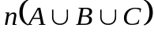 = 320 (80% of 400)
Example 27:
How many natural numbers are there not more than 100, which are not divisible by 2, 3 or 5.
Solution
Let us first calculate the total number not more than 100, which are divisible by 2, 3 or 5
Divisible by 2 n (A) = 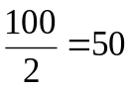
Divisible by 3 n(B) = 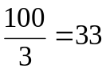
Divisible by 4 n (C) = 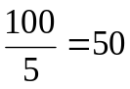
Divisible by both 2 and 3, n (A B) = 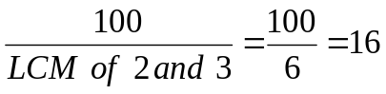
Divisible by both 3 and 5, 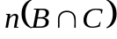 = 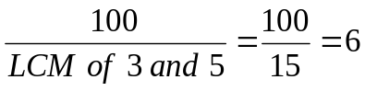
Divisible by both 2 and 5, 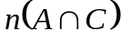 = 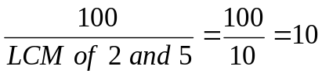
Divisible by 2, 3 and 5, 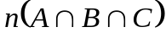 = 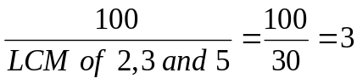
So
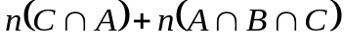
=
So total number is not more than 100, not divisible by 2, 3 or 5 is
Example 28:
In a school there are 200 candidates, 120 study English and 180 study Hindi. How many of them study both subjects?
Solution :
The answer of the question given cannot be determined because we don’t know whether every student study at least one of these subjects or not, there may be a case when certain students don’t read English or Hindi, they study physics.
Problems for practice
Easy
1. Find 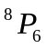
a. 33425 b. 20160 c. 18972 d. 6625
2. Find 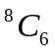
a. 33 b. 32 c. 30 d. 28
3. Find the number of ways in which the letters of the word BIHAR can be rearranged
a. 99 b. 129 c. 119 d. 125
4. Find the number of ways in which the letters of the word AMERICA can be rearranged
a. 2519 b. 2620 c. 1250 d. 2500
5. Find the number of ways in which the letters of the word CALCUTTA can be rearranged
a. 3000 b. 5009 c. 5029 d. 5039
6. In how many ways can you arrange AKSHAY such that vowels do not start the words?
a. 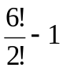 b. 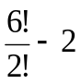 c. 2 x 5! d. 120
Medium
7. How many 4 lettered different words can be formed by using the letters a, b, c and d? (repetitions is allowed).
a. 296 b. 346 c. 440 d. 256
8. How many four numbers can be made by using the digits 2, 3, 4 and 5?
a. 58 b. 512 c. 64 d. None of these
9. How many numbers greater than 4000 can be made by using the digits 2, 3, 4 and 5?
a. 12 b. 14 c. 20 d. 24
10. How many numbers greater than 4000 can be made by using the digits 2, 3, 4 and 5? (repetition of digits are allowed)
a. 120 b. 128 c. 138 d. 130
11. If 4 dices and 3 coins are tossed simultaneously the number of elements in the sample space is____
a. 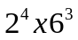 b. 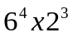 c. 2156 d. 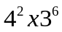
12. A bag contains 6 white and 4 red balls. Three balls are drawn one by one with replacement. What is the probability that all 3 balls are red?
a. 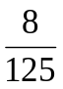 b. 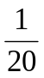 c. 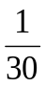 d. 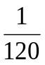
13. In the above question, if 3 balls are drawn one by one with replacement. What is the probability that 2 balls are white and 1 is red?
a. 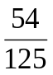 b.  c. d. 
14. In question 12, if the ball be drawn without replacement. What is the probability that 2 are red and 1 is white?
a. 0.1 b. 0.2 c. 0.3 d. 0.4
15. The probability that A will pass the examination is , and the probability that B will pass the examination is . What is the probability that both will pass the examination?
a. b. 1 c.  d. 
16. In Q. No. 15, what is the probability that only one person will pass the examination?
a. 1 b. c. d.
17. In Q. No. 15, what is the probability that the at least one person will pass the examination?
a. 1 b. c. d.
18. In Q. No. 15, what is the probability that no one will pass the examination?
a. 1 b. c.  d.
19. Two cards are drawn together from a pack of 52 cards at random. What is the probability that both are spades?
a. 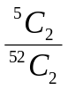 b. 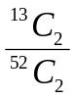 c. 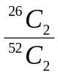 d. 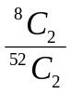
20. In question number 19, what is the probability that both are kings?
a. b. c. d. 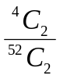
21. In question number 19, what is the probability that one is a spade and one is a heart?
a. 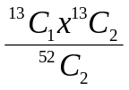 b. 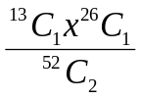 c. 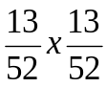 d. 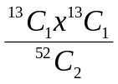
22. In question number 19, what is the probability that exactly one is a king?
a. 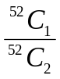 b. 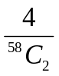 c. 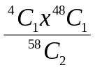 d.
23. In a class of 60 boys, there are 45 boys who play cards and 30 boys play carom. Find how many boys play both games (assuming that every boy play either cards or carom or both)
a. 15 b. 17 c. 20 d. 21
24. In question number 23, find what is the number of students who play cards only?
a. 27 b. 30 c. 32 d. 25
25. In question number 23, find how many boys play carom only?
a. 10 b. 12 c. 15 d. 20
26. Each student in a class of 40, studies at least one of the subjects English, mathematics and economics. 16 study English, 22 economics and 26 mathematics, 5 study English and economics, 14 mathematics and economics and 2 English, economics and mathematics. Find the number of students who study English and mathematics.
a. 10 b. 7 c. 17 d. 27
27. In question number 26, fin the number of students who study English mathematics but not economics.
a. 8 b. 12 c. 7 d. 5
Difficult
28. There are 3 roads from A to B, from B to C there are 4 roads, from C to D there is only 1 road. How many combinations of roads are there from A to D?
a. 11 b. 15 c. 14 d. 12
29. There are 5 question in a questions paper. In how many ways a candidate attempt at least 1 question?
a. 30 b. 34 c. 32 d. 31
30. If two dices are thrown simultaneously, what is the probability that the product of the numbers on their top faces is less than 36?
a. 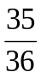 b. c. 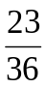 d. 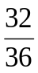

Modern Mathematics
1. 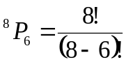
= 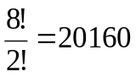
2. 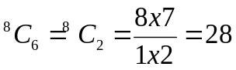
3. Since there are 5 letters in the word
So that total number of rearrangement to 5! – 1! Or 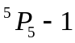 that is 119.
4. In the word AMERICA there are 7 letters and the letter ‘A’ is coming twice.
So the total number of rearrangement
= 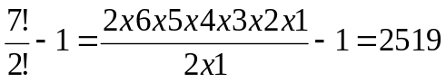
5. In the word CALCUTTA, there are 8 letters
Letter C is coming twice
Letter A is coming twice
Letter T is coming twice
So the total number of rearrangements
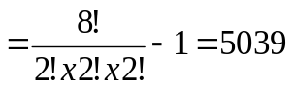
6. If any one of the consonant start, next 5 letters can be arranged in  = 60 ways. And the first consonants itself can be selected in 4 ways. Hence total number of arrangements = 4 x 60 = 120
7. Letter a can be placed in all 4 positions.
Similarly b can be placed in all 4 positions
Similarly c can be placed in all 4 positions
Similarly d can be placed in all 4 positions
So the total number or arrangement its
4 x 4 x 4 x 4 = 256
8. If not mentioned in the questions, you have to assume the repetition is allowed. Hence 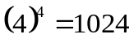
9. Thousand’s place can be filled only with two digits 4 or 5
Hundred’s place can be filled in 3 ways.
Ten’s place can be filled in 2 ways.
Unit’s place can be filled in 1 ways.
So total number of number formed = 2 x 3 x 2 x 1 = 12
10. Thousands place can be filled in two ways.
Hundred’s place can be filled with any of the 4 digits.
Ten’s place can be filled with any of the 4 digits.
Unit’s place can be filled with any of the 4 digits.
So the total number of number formed = 2 x 4 x 4 x 4 = 128.
11. In every dice there are six spaces. So in 4 die it is 6 x 6 x 6 x 6 = 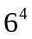 and in every coin there are two spaces. So, in 3 coins it is 2 x 2 x 2.
So the total number of spaces = x 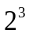
12. P (of Red ball in first attempt) = 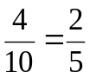
Here probability will remain same for the next two attempt.
Probability = 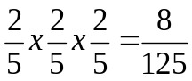
13. P(white ball) = 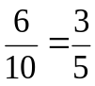 and P(Red ball) = 
Hence probability of 2 white and 1 Red ball is
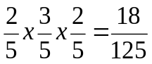
This will be multiplied by 3 as red ball can be attain in any of the attempt. i.e. 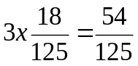
14. The following combinations are possible, first white, second red, third re, or first red, second white, third red or first re, second red, third white
So the probability
= 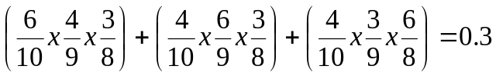
15. Probability that A will pass in exam =
Probability that A will fail in exam =
Probability that B will pass in exam =
Probability B will fail in exam =
Probability that both will pass in the exam = probability that A will pass and probability that B will pas = 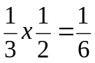
16. Probability that only one person will pass
So the possibility can be either A pass and B fails or A fails and B pass
i.e. (A pass and B fail) or ( A fail and B pass)
= 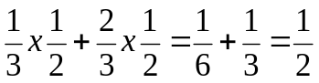
17. Probability that at least one person, will pass, so the possibilities can be (A pass and B fails),or (A fails and B pass) or (Both A and B pass)
i.e. = 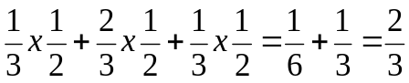
Alternative method : 1 – (None of them pass ) i.e.
(A fails and B fails) = 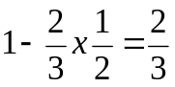
18. The probability that no one will pass
i.e. both A and B fails = 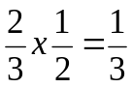
19. There are 13 spades
Two spades out of 13 spades can be taken out in 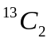 ways
Total number of sample spaces = 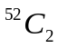
Required probability = 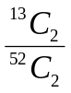
20. There are 4 king
Two kings out 4 kings can be drawn in 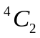 ways.
Required probability 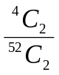
21. There are 12 spades and 13 hears. One spade and one heart can be taken out in 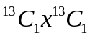 ways
Required probability = 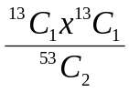
22. There are 4 king. One king can be taken out in 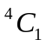 ways. Now out of remaining 48 cards, any one card can be taken out in 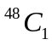 ways.
Red probability = 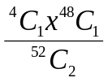
23.
45
30
30 - x
x
45 x
Cards
Carrom

Assume x be the number of boys who play both games.
Then 45 – x + x + 30 – x = 60
 75 – x = 60 x = 15
24. From solution of 23, only students who play cards is 45 – x, i.e. 30 – 15 = 15
25. From solution 23, only students who play carom is 30 – x, i.e.
30 – 15 = 15
12-x
11-x
x
2
5
12
3
22
E

16
M

26
26.

As given in the question 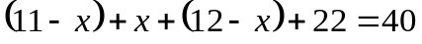 and x = 5. Hence number of students studying both English and Maths = x + 2 = 7
27. From solution 26, those students who study English, Mathematics but not Economics is x, i.e. 5.
28.
B
A
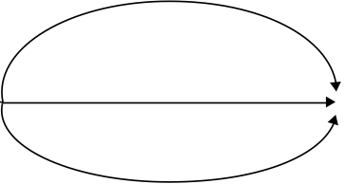
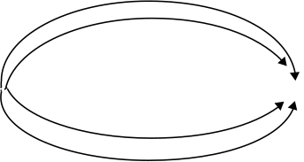
C

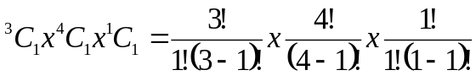
= 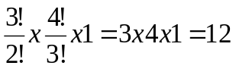 ways
29. Either a candidate will solve the problem or he would not solve. So the probability of solving is p = 1 and probability of not solving is q = 1
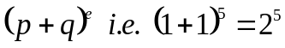
The number of ways of solving at least 1 question is 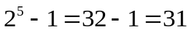
Alternative method:
Number of ways of solving at least 1 question is candidate may solve 1 question out of 5.
or he may solve 2 out of 5
or he may solve 3 out of 5
or he may solve 4 out of 5
or he may solve 5 out of 5
i.e. 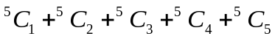
= 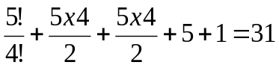
30. If two dices are throws total number of sample spaces = 36
Number of times when product of numbers on their top faces is less than 36.
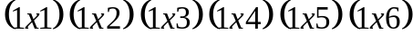
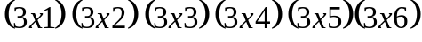
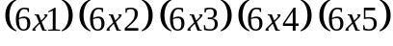
i.e., 35 times
Required probability = 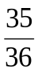
Or 1 – probability of having product 36.
= 1 -  

